Combustion Enthalpy Experiment – Eden Tomes

# Research Question:

*How does the number of carbon atoms in a series of primary alcohols (methanol, ethanol, pentanol) affect the experimental enthalpy of combustion (kJ/g) measured using simple calorimetry?*

# Rationale:

Combustion reactions, the exothermic oxidation of fuels like alcohols, are essential for energy production. The standard enthalpy of combustion (ΔH°C) quantifies the energy released in a complete combustion reaction (e.g., for alcohols: $$C_{n}H_{2n+1}OH_{\left(l\right)}+\frac{3n}{2}O_{2\left(g\right)}→nCO_{2\left(g\right)}+\left(n+1\right)H_{2}O_{\left(l\right)}$$, balanced based on 'n'), making it vital for evaluating fuel efficiency (*Atkins & de Paula*, 2010). Theoretically, ΔH°C reflects the net energy change from bond breaking and formation, calculable from standard enthalpies. Increasing carbon chain length generally leads to a more negative ΔH°C per gram due to greater CO2/H2O production (*Glassman & Yetter*, 2008).

Experimentally, simple calorimetry estimates this value by measuring the temperature change (ΔT) of water heated by the combustion, assuming the heat absorbed by water ($$q=mc∆T$$) equals the heat released by the fuel ($$∆H°C≈−q ÷ mass burned$$). However, highly accurate reference values, like those used for comparison (*NIST*, 2023), are typically determined using bomb calorimetry, which minimizes heat loss unlike the simpler method employed here. Understanding the relationship between carbon content and energy release, even when measured with basic equipment, remains important for fuel comparisons and assessing experimental limitations.

Derived from a base experiment focused on food combustion, this study redirects the investigation towards the enthalpy of combustion for a series of primary alcohols: methanol, ethanol, and pentanol. Key modifications were implemented, altering substances and the calorimetric methodology. This refined approach allows for a targeted examination, using simple calorimetry, of how varying numbers of carbon atoms within this homologous series affects the energy released during combustion, thus addressing the research question more effectively.

Investigating the combustion enthalpies of these specific alcohols provides practical context. Ethanol is a major global biofuel additive (*IEA*, 2021), methanol serves as a fuel and chemical feedstock, and pentanol isomers are researched as potential 'next generation' biofuels (*Gainey & Lawler*, 2020). Comparing the experimentally obtained trend using simple calorimetry against established scholarly values therefore provides valuable data for evaluating the method's limitations and contributes practical evidence relevant to modelling oxygenated fuel combustion.

# Method:

## Original Experiment

Using simple calorimetry, the original experiment measured solid food combustion enthalpy through $$q=mc∆T$$. Pre-weighed food burned below a test tube of water; temperature change and mass burned were measured. The procedure involved single trials and lacked a heat shield, allowing potential heat loss. A full experimental method is detailed in the appendix supplementing this report.

## Modifications

The modified experiment involved several changes. Replacing solid foods with liquid alcohols represented a redirection of the investigation’s purpose, applying the calorimetry method to a different type of substance (fuels). Other changes were refinements aimed at improving the quality of the data. Specifically, incorporating a heat shield enhanced the validity by minimizing heat loss to the surroundings, a significant source of systematic error in the original setup. Replacing the glass thermometer with a digital one increased the precision of temperature readings, improving the accuracy of the calculated temperature change and, consequently, the enthalpy values. Furthermore, conducting three trials for each alcohol, instead of just one, was a key refinement to ensure the reliability of the results by checking for consistency and allowing for the calculation of an average, helping to mitigate the impact of random errors.

## Modified Experiment

The experiment setup used a spirit burner containing the alcohol, with initial and final masses recorded to determine the amount of fuel consumed. For each trial, approximately 200 grams of water was measured in a beaker and then heated in a metal can clamped above the burner. After ignition, the flame heated the water until its temperature had risen by a certain amount (20 degrees for ethanol and pentanol, 10 degrees for methanol). Temperature changes were recorded digitally, and the enthalpy of combustion (ΔH°C) was calculated per gram using $$q=mc∆T\text{.}$$

## Risk Management:

|  |  |  |
| --- | --- | --- |
| **Hazard** | **Identified Risk(s)** | **Control Measure(s)** |
| * Flammable Alcohols (Methanol, Ethanol, Pentanol) * Potential Alcohol Spills * Burner Malfunction | * Fire | * Handled liquids in well-ventilated area, away from ignition sources. * Experiment conducted on non-flammable surface, clear of combustibles. * Careful dispensing of alcohols. * Flame contained by heat shield. * Fire extinguisher and blanket nearby. |
| * Open Flame * Heated Apparatus (Metal can, burner) | * Burns (to person) | * Safety glasses worn constantly. * Tongs used for handling hot equipment. * Heat shield provided some barrier. |
| * Potential Spillage * Glassware Breakage | * Equipment / Lab Damage * Injury | * Metal can was used instead of fragile glass. * Constant monitoring for spills or malfunctions allows quick intervention. * Experiment conducted on non-flammable surface. |

# Results:

*Sample Calculations for Methanol Trial 1*

* Combustion enthalpy $$∆H°C=\frac{−mc∆T}{m_{alcohol}}=\frac{−199.8×4.184×10}{136.3−134.9}≈−5971 \text{J}\text{/}\text{g}=−5.971 \text{kJ}\text{/}\text{g}$$
* Uncertainty in water mass $$=0.05g$$  
  Relative uncertainty $$=\frac{0.05}{199.8}≈0.00025$$
* Uncertainty in temperature measurements $$=0.05°C$$  
  Relative uncertainty $$=\frac{\sqrt{{\left(0.05\right)}^{2}+{\left(0.05\right)}^{2}}}{36.7−26.7}≈0.00707$$
* Uncertainty in alcohol mass measurements $$=0.05g$$  
  Relative uncertainty $$=\frac{\sqrt{{\left(0.05\right)}^{2}+{\left(0.05\right)}^{2}}}{136.3−134.9}≈0.0505$$
* Sum of relative uncertainty $$=\sqrt{{0.00025}^{2}+{0.00707}^{2}+{0.0505}^{2}}≈0.051$$
* Absolute uncertainty $$=\sqrt{{0.00025}^{2}+{0.00707}^{2}+{0.0505}^{2}}×5.971 \text{kJ}\text{/}\text{g}≈±0.305 \text{kJ}\text{/}\text{g}$$

Figure 1 (Results Table):

All displayed values are rounded to 3 decimal places

|  |  |  |  |  |  |
| --- | --- | --- | --- | --- | --- |
| **Alcohol** | **Carbon Atoms** | **Average Combustion Enthalpy (kJ/g)** | **Mol. Weight (g/mol)** | **Theoretical Value (kJ/g)**  **(*NIST*, 2023)** | **% Error** |
| Methanol | 1 | -6.291 ± 0.337 | 32.042 | -22.648 | 72.222% |
| Ethanol | 2 | -5.907 ± 0.201 | 46.068 | -29.687 | 80.104% |
| Pentanol | 5 | -11.703 ± 0.637 | 88.148 | -37.788 | 69.030% |

Figure 2 (Num. Of Carbon Atoms vs Combustion Enthalpy):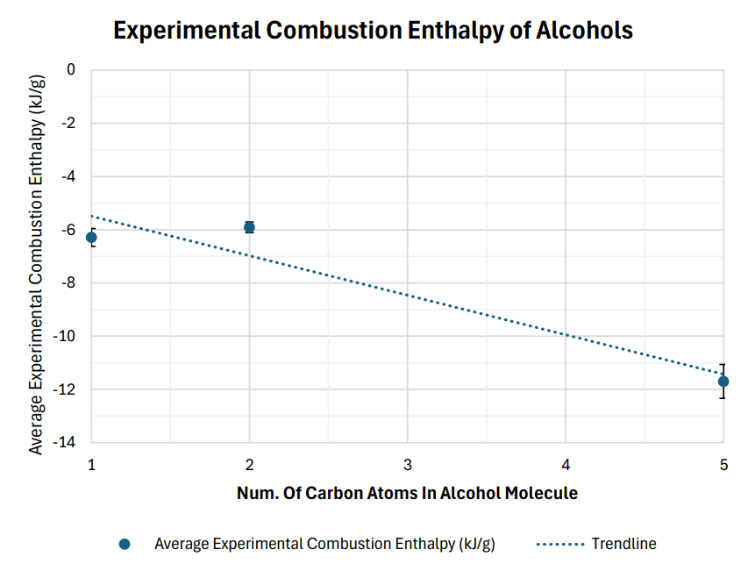

Figure 1 contains the average experimental combustion enthalpies of the alcohols, along with the number of carbon atoms in their molecules. The data displays a clear trend: as the number of carbon atoms increases from one (methanol) to five (pentanol), the average experimental combustion enthalpy becomes more negative, indicating a larger amount of energy released per gram of alcohol. Methanol, with one carbon atom, exhibits an average combustion enthalpy of -6.291 kJ/g. Ethanol, containing two carbon atoms, shows a similar value of -5.907 kJ/g. Pentanol, with five carbon atoms, demonstrates the most negative average combustion enthalpy of -11.703 kJ/g.

The graphical representation in Figure 2 visually confirms this observation, depicting a trendline with a downward slope as the number of carbon atoms increases. While there is a similarity in the experimental values for methanol and ethanol, the combustion enthalpy of pentanol is notably more exothermic, approximately 1.98 times greater than that of ethanol and 1.86 times greater than methanol. This quantitative difference highlights the substantial impact of increasing carbon chain length on the energy released during combustion within this series of alcohols. The visual representation in Figure 2, alongside the numerical data in Figure 1, supports the hypothesis that increasing carbon atoms in alcohol molecules leads to a greater magnitude of combustion enthalpy.

## Theoretical Explanation

The combustion of alcohols involves breaking C-H and C-C bonds and forming new bonds in the products, notably CO2 and H2O. Theoretically, as the number of carbon atoms increases, the total energy released during these bond rearrangements should also increase, leading to a more exothermic reaction (*Glassman & Yetter*, 2008). This is reflected in the increasing magnitude of the theoretical values (-22.648, -29.687, -37.788 kJ/g for methanol, ethanol, and pentanol respectively). Experimentally, the observation that pentanol shows a larger magnitude of combustion enthalpy than methanol or ethanol is broadly consistent with this theoretical expectation. However, the near-identical experimental values for methanol (-6.291 kJ/g) and ethanol (-5.907 kJ/g) contradict the expected trend and indicate significant issues within the experimental data.

These discrepancies are underscored by high percent errors against theoretical NIST values (72.22% - 80.10%). This high error partially stems from the simple calorimetry method's significant heat loss compared to controlled bomb calorimetry used for theoretical values (*Lower*, 2017). This heat loss underestimates the energy released, yielding dramatically lower experimental enthalpy values. Additionally, variability in experimental conditions and equipment likely contributed to anomalies such as ethanol's high error. Combined, these errors likely masked the smaller true enthalpy difference between methanol and ethanol, leading to their unexpectedly similar results.

# Evaluation of Evidence:

The experimental results indicate a trend of increasing combustion enthalpy with a higher number of carbon atoms in alcohol molecules. Pentanol (5 carbon atoms) demonstrated a significantly more exothermic combustion enthalpy compared to methanol (1 carbon) and ethanol (2 carbons), aligning with theoretical predictions based on bond enthalpies taken from the NIST Chemistry Web Book (*NIST*, 2023)*.* However, the experimental values for methanol and ethanol were notably similar, failing to show the expected increase in combustion enthalpy with the additional carbon atom. This discrepancy suggests that while the overall trend is observed, the relationship may not be linear within the experimental data, and that experimental limitations likely influenced the results.

## Limitations of Evidence:

Key limitations related to the experiment's scope and size included the small sample size, investigating only three alcohols (methanol, ethanol, and pentanol). This limited range constrained the ability to firmly establish the consistency and generalizability of the relationship between carbon chain length and combustion enthalpy. Confirming the observed trend, especially the methanol/ethanol anomaly, would require testing a broader range of alcohols. Furthermore, the reliance on externally sourced pentanol data imposed a significant limitation, restricting the scope of conclusions drawn from this experiment's directly collected data and introducing uncertainty regarding the direct comparability of results obtained under potentially different conditions.

## Sources of Error Affecting Reliability:

Sources of error affecting the reliability (precision and consistency) of measurements included instrument precision and experimental variability. The use of instruments with readings limited to one decimal place for temperature and mass introduced measurement uncertainty, potentially impacting the precision of calculated energy values. Conducting trials on different days also introduced variability, potentially involving different specific equipment (e.g., spirit burners, as indicated by ethanol trial 2's anomalous mass). This variability could affect the consistency of individual trial results and the precision of the calculated average enthalpy values.

## Sources of Error Affecting Validity:

Systematic errors affecting the validity (the accuracy with which the experimental design could answer the research question) arose primarily from the simple calorimetry setup and the use of borrowed data. The open setup inherently allowed significant heat loss to the surroundings, a systematic error preventing accurate determination of the actual combustion enthalpy. Additionally, comparing directly collected methanol/ethanol data with borrowed pentanol data potentially compromised validity; unknown systematic differences in experimental setup, technique, or ambient conditions between the groups could mean the comparison does not accurately reflect the true effect of carbon atoms on an alcohol’s combustion enthalpy, thereby limiting the accuracy of the answer to the research question.

## Improvements and Extensions:

* **Expand Alcohol Range:** A possible extension that would strengthen the evidence of future experiments is the inclusion of a broader range of alcohols, such as propanol (3 carbon atoms) and butanol (4 carbon atoms). Testing a more comprehensive series of fuels would broaden the scope of the resulting experimental data and help to determine if the observed trend is consistent and to identify any deviations or non-linearities more definitively.
* **Enhance Calorimetry Accuracy:** A possible improvement to the method that would minimise data errors within the current experimental scope is the use of bomb calorimetry. Bomb calorimetry is a more sophisticated technique that provides highly controlled and insulated combustion conditions (*Lower*, 2017), greatly reducing heat loss and leading to more accurate and reliable enthalpy of combustion values compared to the simple calorimetry setup used in this experiment.
* **Increase Trials:** Increasing the number of trials for each alcohol and ensuring all trials are conducted under consistently controlled conditions is an improvement that would reduce the effect of errors evident in data collection. This change would allow for a more precise determination of average combustion enthalpy values and a better assessment of experimental uncertainty, enhancing the robustness and statistical significance of the results.

# Conclusion:

The experimental evidence provides partial support for the research question, demonstrating that increasing the number of carbon atoms in alcohols correlates with a greater magnitude of combustion enthalpy, as pentanol (5 carbons) released significantly more energy per gram (-11.703 kJ/g) compared to methanol (-6.291 kJ/g) and ethanol (-5.907 kJ/g). The trend aligns with theoretical predictions of higher enthalpy for molecules with more carbon atoms. However, the minimal difference between methanol and ethanol suggests non-linear behaviour or experimental limitations, such as high percentage errors (69.030–80.104%) and reliance on borrowed pentanol data. A broader range of alcohols and improved calorimetry could clarify this relationship.

# References:

* Atkins, P. and De Paula, J. (2010). *Physical Chemistry*. 9th ed. [online] Oxford University Press. Available at: <https://tech.chemistrydocs.com/Books/Physical/Atkins-Physical-Chemistry-9e-by-Peter-Atkins-and-Julio-de-Paula.pdf> [Accessed 3 Mar. 2025].
* Gainey, B. and Lawler, B. (2020). The role of alcohol biofuels in advanced combustion: An analysis. *Fuel*, [online] 283, p.118915. doi: <https://doi.org/10.1016/j.fuel.2020.118915>.
* Glassman, I. and Yetter, R.A. (2008). *Combustion (Fourth Edition)*. [online] Available at: <https://research.iaun.ac.ir/pd/ekianpour/pdfs/UploadFile_8224.pdf> [Accessed 3 Mar. 2025].
* International Energy Agency (IEA) (2021). *World Energy Outlook 2021 – Analysis*. [online] IEA.org. Available at: <https://www.iea.org/reports/world-energy-outlook-2021> [Accessed 3 Mar. 2025].
* Lower, S. (2017). *14.5: Calorimetry*. [online] Chemistry LibreTexts. Available at: <https://chem.libretexts.org/Bookshelves/General_Chemistry/Chem1_(Lower)/14%3A_Thermochemistry/14.05%3A_Calorimetry>.
* National Institute of Standards and Technology (NIST) (2023). *NIST Chemistry WebBook - SRD 69*. [online] NIST. Available at: <https://webbook.nist.gov/chemistry/> [Accessed 10 Mar. 2025].

# Appendix:

## Full results/calculation tables

|  |  |  |  |  |  |  |  |  |
| --- | --- | --- | --- | --- | --- | --- | --- | --- |
| **Methanol** | Alcohol Mass (g) | Water Temp (°C) | Water Mass (g) | Combustion Enthalpy (kJ/g) | Theoretical / Researched Value (kJ/g) | Absolute Uncertainty | Percentage / Relative Uncertainty | Percentage Error |
| Trial 1 Before | 136.3 | 26.7 | 199.8 |  |  |  |  |  |
| Trial 1 After | 134.9 | 36.7 | 199.8 | -5.971165714 | -22.64846966 | 0.304534312 | 5.100081405 | 73.6355% |
| Trial 2 Before | 134.9 | 26.8 | 200.2 |  |  |  |  |  |
| Trial 2 After | 133.6 | 36.8 | 200.2 | -6.44336 | -22.64846966 | 0.35342533 | 5.485109167 | 71.5506% |
| Trial 3 Before | 133.6 | 27.3 | 200.7 |  |  |  |  |  |
| Trial 3 After | 132.3 | 37.3 | 200.7 | -6.459452308 | -22.64846966 | 0.354307992 | 5.485108884 | 71.4795% |
| Average: |  |  |  | -6.291326007 | -22.64846966 | 0.337422545 | 5.356766485 | 72.2218% |

|  |  |  |  |  |  |  |  |  |
| --- | --- | --- | --- | --- | --- | --- | --- | --- |
| **Ethanol** | Alcohol Mass (g) | Water Temp (°C) | Water Mass (g) | Combustion Enthalpy (kJ/g) | Theoretical / Researched Value (kJ/g) | Absolute Uncertainty | Percentage / Relative Uncertainty | Percentage Error |
| Trial 1 Before | 162.1 | 25.5 | 200 | -8.009371429 | -29.68655032 | 0.27116487 | 3.385594895 | 73.0202% |
| Trial 1 After | 160 | 45.6 | 200 |  |  |  |  |  |
| Trial 2 Before | 160 | 27.7 | 202.9 |  |  |  |  |  |
| Trial 2 After | 141.8 | 47.6 | 202.9 | -0.928229596 | -29.68655032 | 0.004892524 | 0.527081258 | 96.8732% |
| Trial 3 Before | 141.8 | 26.6 | 199.4 |  |  |  |  |  |
| Trial 3 After | 139.9 | 46.6 | 199.4 | -8.781995789 | -29.68655032 | 0.328310943 | 3.738454798 | 70.4176% |
| Average: |  |  |  | -5.906532271 | -29.68655032 | 0.201456112 | 2.550376984 | 80.1037% |

|  |  |  |  |  |  |  |  |  |
| --- | --- | --- | --- | --- | --- | --- | --- | --- |
| **Pentanol** | Alcohol Mass (g) | Water Temp (°C) | Water Mass (g) | Combustion Enthalpy (kJ/g) | Theoretical / Researched Value (kJ/g) | Absolute Uncertainty | Percentage / Relative Uncertainty | Percentage Error |
| Trial 1 Before | 165 | 27.5 | 203.1 |  |  |  |  |  |
| Trial 1 After | 164 | 47.6 | 203.1 | -17.08038504 | -37.78761223 | 1.209266718 | 7.079856311 | 54.7990% |
| Trial 2 Before | 164 | 28.1 | 205.6 |  |  |  |  |  |
| Trial 2 After | 162.4 | 48.2 | 205.6 | -10.8066444 | -37.78761223 | 0.479108661 | 4.43346374 | 71.4016% |
| Trial 3 Before | 161.9 | 23.8 | 198.5 |  |  |  |  |  |
| Trial 3 After | 159.6 | 43.8 | 198.5 | -7.221947826 | -37.78761223 | 0.223500679 | 3.094742368 | 80.8881% |
| Average: |  |  |  | -11.70299242 | -37.78761223 | 0.637292019 | 4.869354139 | 69.0296% |

## Full method of original experiment

Burning Food

The standard enthalpy of combustion (∆*Hc*) is the enthalpy change when one mole of a substance undergoes complete combustion with oxygen at standard states, under standard conditions.

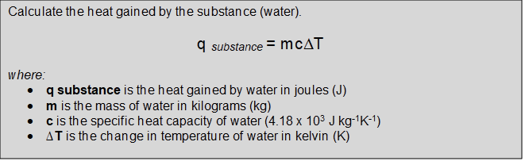

Materials

* Food
* Bunsen burner
* Trays for holding food
* Test tubes
* Thermometer
* 10mL measuring cylinder
* Retort stand and clamp
* Matches
* Tripod and gauze mat
* Tongs

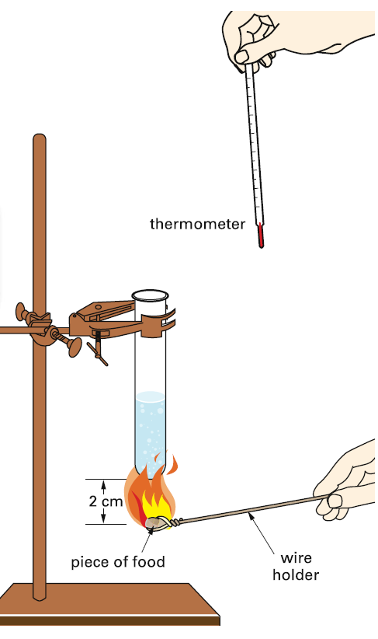

Procedure/Method

1. Set up the equipment as shown. The test tube should be clamped so that it sits just above the food tray.
2. Use a measuring cylinder to transfer 10mL of cold water to the test tube.
3. Record the initial temperature of the water using a thermometer.
4. Weigh the food as accurately as possible, and record the mass.
5. Light the bunsen burner. Put the food in the flame. As soon as it catches fire, rest it on the tripod so that it sits about 2cm under the test tube. Monitor the temperature and observe the flame.
6. When the food stops burning, stir the water gently with the thermometer and record the final temperature.
7. Repeat the experiment with three different food types.